Project Tracker

Iteration #1 Plan

9/29/2014 – 10/12/2014

# Revision History

|  |  |  |
| --- | --- | --- |
| **Author** | **Date** | **Description** |
| M. Rudner | 10/3/2014 | Initial Release |
| M. Sunderland | 10/3/2014 | Initial Release |

# Objectives

The purpose of this iteration is to create a working skeleton of the system. At the end of this iteration, users should be able to:

* View a table of submitted project ideas
* Submit a project idea
* Edit previous posts
* Delete previous posts
* Show post details

# Use Cases

The following use cases are involved in this iteration:

* UC001: Submit a project idea – The basic flow of this use case will be implemented.
* UC002: View a table of submitted project idea – The basic flow of this use case will be implemented.

# Task Schedule

|  |  |  |  |  |  |  |  |
| --- | --- | --- | --- | --- | --- | --- | --- |
| **Story ID** | Task | Effort | | Completion Date | | Owner | **Status** |
| **Est.** | **Actual** | **Est.** | **Actual** |
| S18 | Create database schema | 2 hours | 2 hours | 10/5 | 10/5 | Rudner, Ranney | Finished |
| S20 | Create initial Visual Studio project and upload to GitHub | 15 minutes | 15 minutes | 10/5 | 10/5 | Withee | Finished |
| S02, S03 | Create project dropdown menu to navbar | 1 hour | 45 minutes | 10/10 | 10/11 | Suenaga | Finished |
| S02, S03, S16, S13 | Create initial project views | 4 hours | 4 hours | 10/10 | 10/8 | Suenaga | Finished |
| S18 | Added scaffolding for Employee & School | 2 hours | 1 hour | 10/10 | 10/12 | Suenaga | Finished |
| S02, S03, S16, S13, S18 | Create initial Employee, Project, and School controllers | 1 hour | 1 hour | 10/10 | 10/8 | Suenaga | Finished |

# Task Pictures

## Showing Dropdown menu:

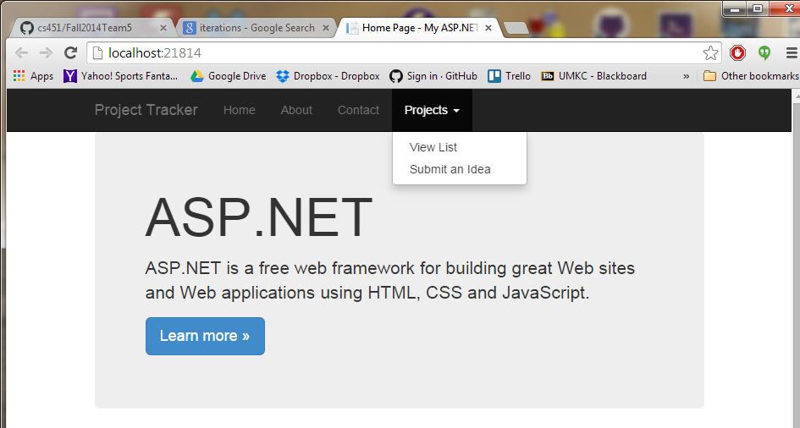

## Showing submit idea page:

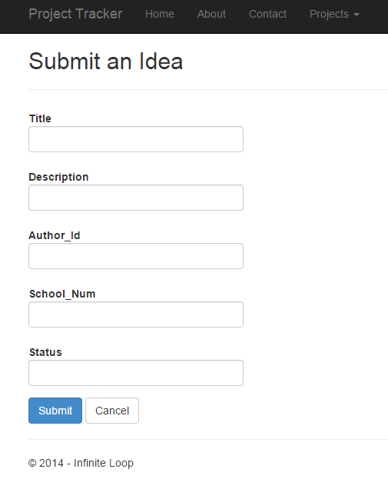

## Showing “Project ideas” page:

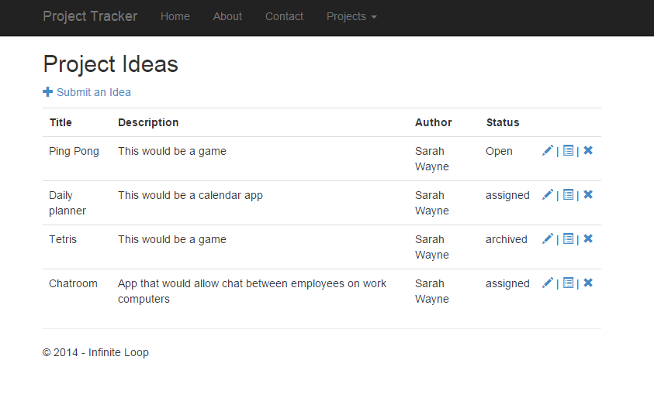

## Showing “Edit Project” page:

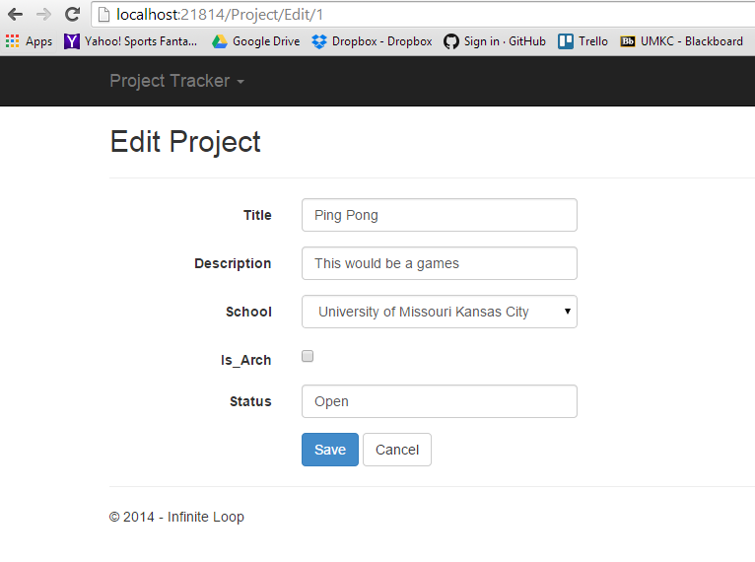

## Showing “Delete” page:

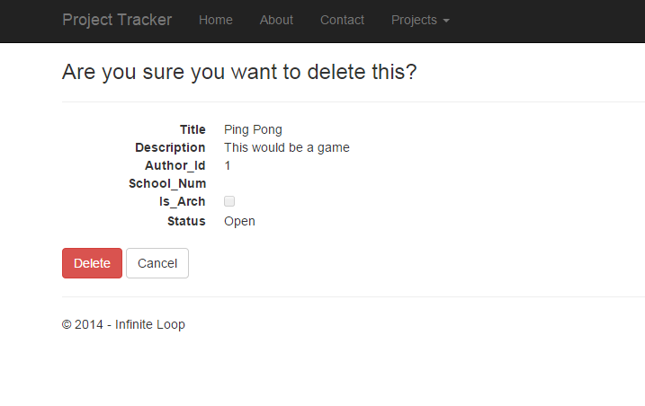

## Showing “Details” page:

